**JAVASCRIPT ASSIGNMENT**

Submitted By

Duvvuri Naga Sai Aparna

ENG18CS0096

1.Create a web page with JS to validate age (onblur event) greater than 18 and count the no of words in the description field (onclick event)

<!DOCTYPE html>

<html lang="en">

<head>

  <meta charset="UTF-8">

  <meta http-equiv="X-UA-Compatible" content="IE=edge">

  <meta name="viewport" content="width=device-width, initial-scale=1.0">

  <title>Assignment 2 qn 1</title>

  <!-- <script src="j.js"></script> -->

  <script>

    function agevalidation(){

      let x = document.getElementById("age").value;

      let text;

      if(isNaN(x) || x < 18)

      text = "Invalid!";

      else

      text = "Valid!";

    document.getElementById("agev").innerHTML=text;

    }

    function countr(){

      var text = document.getElementById("desc").value;

      var num = 1;

      for(var i = 0; i < text.length; i++){

      var currentCharacter = text[i];

      if(currentCharacter == " ")

      num += 1;

      }

      document.getElementById("count").innerHTML = num;

    }

  </script>

</head>

<body>

  <h2 style="text-align: center;">Age verification!</h2>

  <form style="text-align: center;" action="">

    <label for="age">Please enter your age here: </label>

    <input type="text" name="age" id="age" placeholder="Your Age..." onblur="agevalidation()">

    <span id="agev"></span><br><br>

    <label for="desc">Enter a description about yourself!: </label>

    <input name="desc" id="desc" placeholder="Something about yourself..." style="width: 50ch; height: 10ch;"><br><br>

    <button type="button" onclick="countr()">Count!</button>

    <p id="count"></p>

  </form>

</body>

</html>

Output:

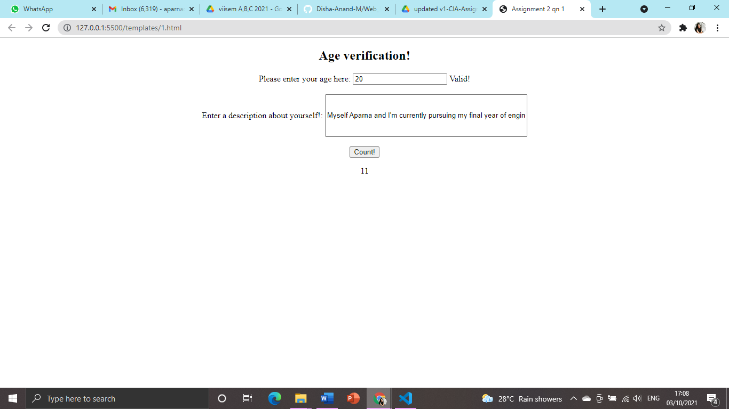

2. Create a Student registration form .A function checks whether the

roll number is a 7 - digit numeric value at the client side . If it is less

that 7 digit alert box is invoked.(The form is invoked when the form is

submitted before going to the server side.

<!DOCTYPE html>

<html lang="en">

<head>

  <meta charset="UTF-8">

  <meta http-equiv="X-UA-Compatible" content="IE=edge">

  <meta name="viewport" content="width=device-width, initial-scale=1.0">

  <title>Assignment 2 Qn 2</title>

  <script>

    function validate(){

      let x = document.getElementById("roll").value;

      var num = /^[0-9]+$/;

      if(!x.match(num))

      alert("The roll number must be of numeric value!");

      else if(x.toString().length != 7)

      alert("The roll no. must be of size 7!");

      else

      alert("Valid!");

    }

  </script>

</head>

<body style="text-align: center;">

  <h2>Student Registration form</h2>

  <form action="">

    <label for="name">Enter your name:</label>

    <input type="text" name="name" id="name" placeholder="Your name..."><br><br>

    <label for="roll">Enter your Roll Number:</label>

    <input type="text" name="roll" id="roll" placeholder="Your roll number..."><br><br>

    <label for="course">Enter the courses you attend:</label>

    <input type="text" name="course" id="course" placeholder="Your courses..." style="width: 50ch; height: 10ch;"><br><br>

    <input type="submit" onclick="validate()" placeholder="Submit">

  </form>

</body>

</html>

Output:

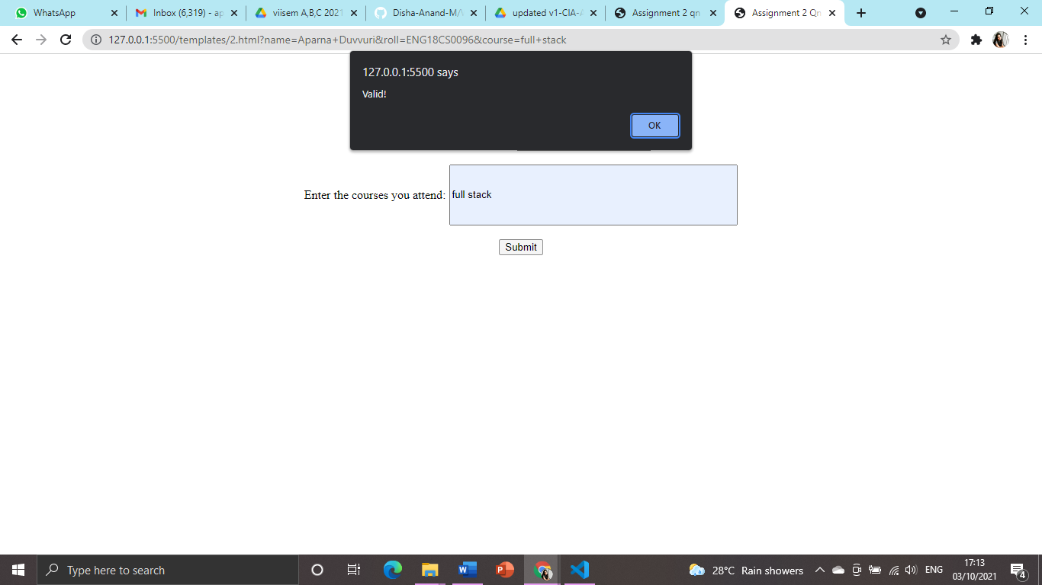

3. Write a JavaScript program depicting the animation of rotating a line .You should be able to rotate the line fast and slow(make respective buttons to do the same)

<!DOCTYPE html>

<html lang="en">

<head>

  <meta charset="UTF-8">

  <meta http-equiv="X-UA-Compatible" content="IE=edge">

  <meta name="viewport" content="width=device-width, initial-scale=1.0">

  <title>Assignment 2 Qn 3</title>

  <script>

    var looper;

    var degrees = 0;

    speed = 200;

    function faster(){

        speed = speed - 50;

        rotateAnimation(el);

      }

      function slower(){

        speed = speed + 50;

        rotateAnimation(el);

      }

    function rotateAnimation(el){

      var elem = document.getElementById(el);

      elem.style.transform = "rotate("+degrees+"deg)";

      looper = setTimeout('rotateAnimation(\''+el+'\','+speed+')',speed);

      degrees++;

      if(degrees > 359){

        degree = 1;

      }

    }

  </script>

</head>

<body>

  <img src="line.png" alt="line" id="line" style="height: 1000px;"><br><br>

  <script>rotateAnimation("line");</script>

  <button type="button" name="fast" id="fast" onclick="faster()" style="font-size: 100px;">Rotate Faster!</button>

  <button type="button" name="slow" id="slow" onclick="slower()" style="font-size: 100px;">Rotate Slower!</button>

</body>

</html>

Output:

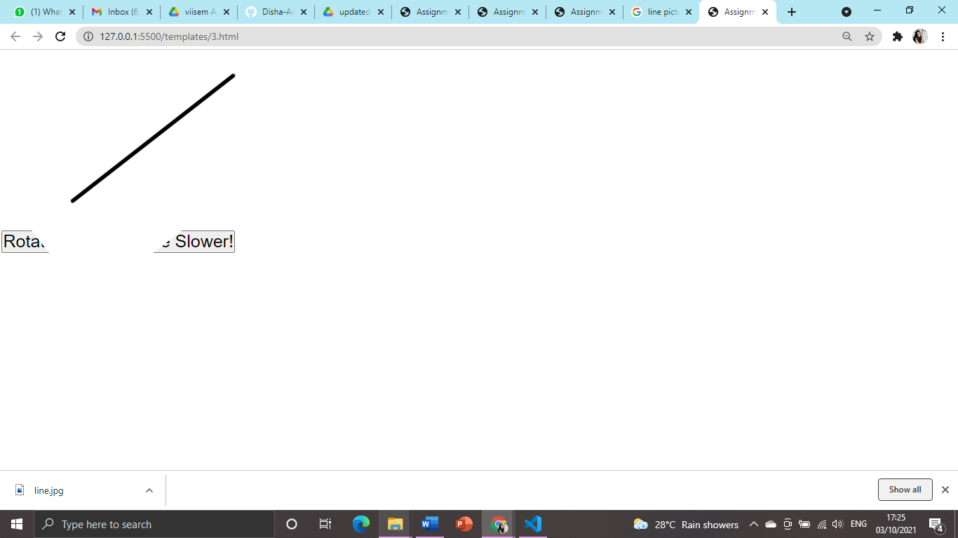

4. 5.MAC-address of a network interface consists of 6 two-digit hex

numbers separated by a colon.

For instance: &#39;01:32:54:67:89:AB&#39;.

Write a regexp that checks whether a string is MAC-address.

<!DOCTYPE html>

<html lang="en">

<head>

  <meta charset="UTF-8">

  <meta http-equiv="X-UA-Compatible" content="IE=edge">

  <meta name="viewport" content="width=device-width, initial-scale=1.0">

  <title>Assignment 2 Qn 5</title>

  <script>

    function validate(){

      let x = document.getElementById("macaddr").value;

      var pattern = "^([0-9A-Fa-f]{2}[:-]){5}([0-9A-Fa-f]{2})|([0-9a-fA-F]{4}\\.[0-9a-fA-F]{4}\\.[0-9a-fA-F]{4})$";

      if(x.match(pattern))

      alert("Valid mac address!");

      else

      alert("Invalid mac address!");

    }

  </script>

</head>

<body style="text-align: center;">

  <h2>Mac Address Validation</h2>

  <form action="">

    <label for="macaddr">Enter a mac address:</label>

    <input type="text" name="macaddr" id="macaddr" placeholder="Mac Address..."><br><br>

    <input type="submit" onclick="validate()" placeholder="Validate">

  </form>

</body>

</html>

Output:

